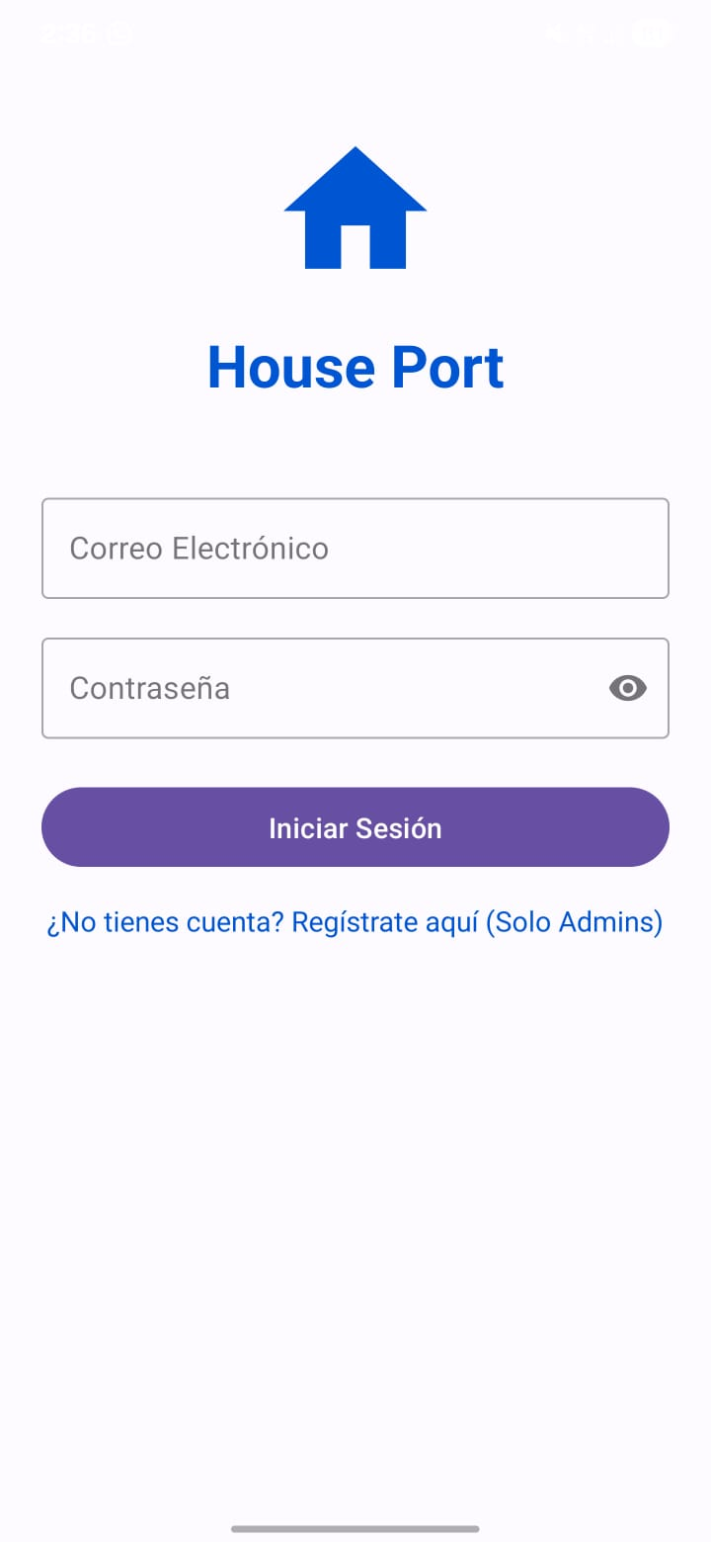
@Composable
fun LoginScreen() {
Column(
modifier = Modifier.fillMaxSize().padding(24.dp),
horizontalAlignment = Alignment.CenterHorizontally,
verticalArrangement = Arrangement.Center
) {
Icon(
imageVector = Icons.Default.Home,
contentDescription = null,
modifier = Modifier.size(100.dp),
tint = Color(0xFF0056D2) // Azul del logo
)
Text(
text = "House Port",
fontSize = 32.sp,
fontWeight = FontWeight.Bold,
color = Color(0xFF0056D2)
)
Spacer(modifier = Modifier.height(40.dp))

OutlinedTextField(
value = "", onValueChange = {},
label = { Text("Correo Electrónico") },
modifier = Modifier.fillMaxWidth()
)
Spacer(modifier = Modifier.height(16.dp))

OutlinedTextField(
value = "", onValueChange = {},
label = { Text("Contraseña") },
visualTransformation = PasswordVisualTransformation(),
trailingIcon = { Icon(Icons.Default.Visibility, null) },
modifier = Modifier.fillMaxWidth()
)
Spacer(modifier = Modifier.height(24.dp))

Button(
onClick = { /* Navegar */ },
modifier = Modifier.fillMaxWidth().height(50.dp),
colors = ButtonDefaults.buttonColors(containerColor = Color(0xFF6750A4))
) {
Text("Iniciar Sesión", color = Color.White)
}

TextButton(onClick = { /* Registro */ }) {
Text("¿No tienes cuenta? Regístrate aquí (Solo Admins)", color = Color(0xFF0056D2))
}
}
}

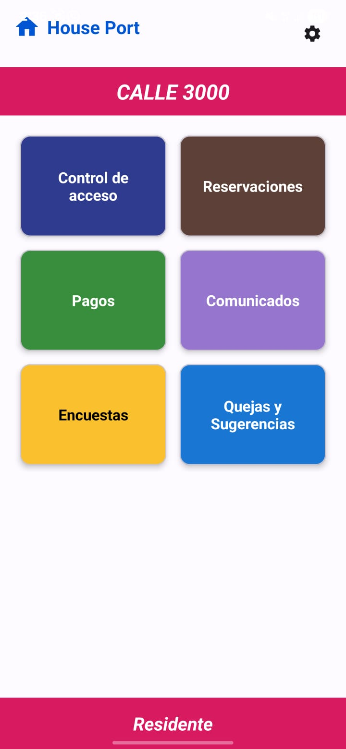
@Composable
fun DashboardScreen() {
Column(modifier = Modifier.fillMaxSize()) {
// Toolbar superior
Row(modifier = Modifier.fillMaxWidth().padding(16.dp), horizontalArrangement = Arrangement.SpaceBetween) {
Icon(Icons.Default.Home, null, tint = Color(0xFF0056D2))
Text("House Port", fontWeight = FontWeight.Bold, color = Color(0xFF0056D2))
Icon(Icons.Default.Settings, null)
}

// Banner Rosa
Box(modifier = Modifier.fillMaxWidth().background(Color(0xFFD81B60)).padding(12.dp)) {
Text("CALLE 3000", color = Color.White, modifier = Modifier.align(Alignment.Center), fontStyle = FontStyle.Italic)
}

// Rejilla de botones
LazyVerticalGrid(
columns = GridCells.Fixed(2),
contentPadding = PaddingValues(16.dp),
verticalArrangement = Arrangement.spacedBy(16.dp),
horizontalArrangement = Arrangement.spacedBy(16.dp)
) {
val items = listOf(
"Control de acceso" to Color(0xFF303F9F),
"Reservaciones" to Color(0xFF5D4037),
"Pagos" to Color(0xFF388E3C),
"Comunicados" to Color(0xFF9575CD),
"Encuestas" to Color(0xFFFBC02D),
"Quejas y Sugerencias" to Color(0xFF1976D2)
)

items(items) { item ->
Card(
modifier = Modifier.height(120.dp),
colors = CardDefaults.cardColors(containerColor = item.second)
) {
Box(Modifier.fillMaxSize(), contentAlignment = Alignment.Center) {
Text(item.first, color = Color.White, textAlign = TextAlign.Center, fontWeight = FontWeight.Bold)
}
}
}
}

Spacer(modifier = Modifier.weight(1f))

// Footer
Box(modifier = Modifier.fillMaxWidth().background(Color(0xFFD81B60)).padding(8.dp)) {
Text("Residente", color = Color.White, modifier = Modifier.align(Alignment.Center), fontWeight = FontWeight.Bold)
}
}
}

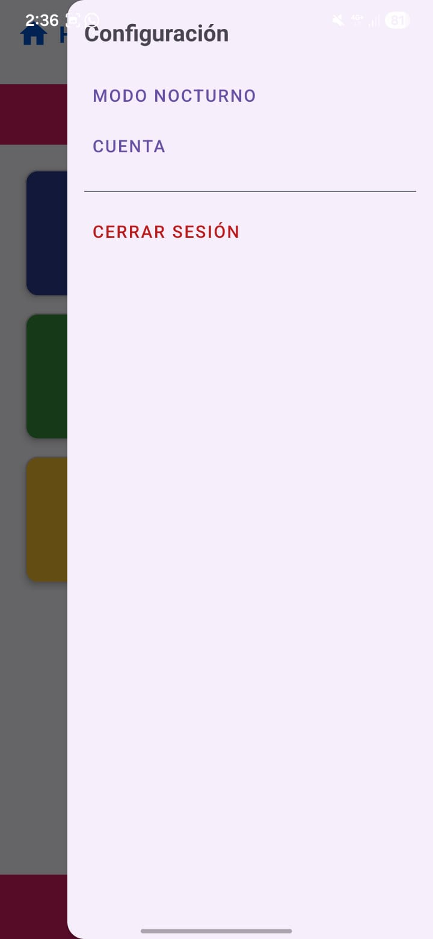
@Composable
fun SettingsMenu() {
Column(
modifier = Modifier.fillMaxHeight().fillMaxWidth(0.7f).background(Color(0xFFF5F0F6)).padding(16.dp)
) {
Text("Configuración", fontSize = 20.sp, fontWeight = FontWeight.Bold, color = Color.DarkGray)
Spacer(modifier = Modifier.height(24.dp))

Text("MODO NOCTURNO", color = Color(0xFF6750A4), fontWeight = FontWeight.SemiBold)
Spacer(modifier = Modifier.height(16.dp))

Text("CUENTA", color = Color(0xFF6750A4), fontWeight = FontWeight.SemiBold)

Divider(modifier = Modifier.padding(vertical = 16.dp))

Text(
"CERRAR SESIÓN",
color = Color.Red,
fontWeight = FontWeight.Bold,
modifier = Modifier.clickable { /* Logout */ }
)
}
}

